

OATS (Oracle Application Testing Suite) Frame Work Design
Version: 01.03
Author: IBM Global Services

Table of Contents
1. Background 3
2. Purpose 3
3. Intended Audience 3
4. Software Test Automation Objective 3
5. Manual Testing Vs Automated Testing 4
6. System Environment/OATS Configuration 4
7. Application connectivity with tool 5
8. Goals and Objectives of Software Test Automation FrameWork 5
9. FrameWork Setup (DDT) 6
10. FrameWork Structure 7
11. Pictorial diagram – How it works 8
12. Open Script code snippet 9
13. Test Results 10
14. Test Case Execution Results 11
15. OTM (Oracle Test Manager) 11
16. Analysis and Conclusion 13
17. Risk 13

Background
This document makes understanding on testing between the various application of the project like EBS, Fusion, web etc. with OATS.
This design document describes:
- Set up the Framework
- Development of automated test scripts using Open Script tool
- Describe the test case run using OTM
- Uses of development environments for Test
- Approach to verifying and reporting test results

Purpose
Testing frameworks are an essential part of any successful automated testing process. They can reduce maintenance costs and testing efforts and will provide a higher return on investment (ROI) for QA teams looking to optimize their testing processes.
Framework is a guide line or set up rules which is everyone needs to follow to get the effective results.

Intended Audience
The target audience of the document includes all parties interested in or involved in testing the Ma’aden account.
The following have been identified as the audience for this document.
- IT Test Team
- Project Managers
- Business Analysts
- Senior Leadership
- Developers
- Data Architects
- Systems Architects

Software Test Automation Objective
Below are the test automation objectives
- To reduce Testing Cost and Time.
- To reduce Redundancy.
- To speed up the Testing Process.
- To help improve Quality.
- To improve Test coverage.
- To reduce Manual Intervention.

Manual Testing Vs Automated Testing
Manual Testing
- Time consuming
- Low reliability
- Human resources
- Inconsistent
Automated Testing
- Speed
- Repeatability
- Coverage
- Reliability
- Reusability

System Environment/OATS Configuration
OATS (Oracle Application Testing Suite) has installed on Jump Server2(172.17.11.39).
To access the OTA server,
- Login with Login to Jump Server 1 (10.2.2.150) using own ID
- Login to Jump Server 2 (172.16.6.60) using own id
- Login to Jump Server3 (172.17.11.39) with user id- OBIDevAdmin2
- Open with OpenScript tool using administrator option to generate the script.
To access the OTM (Oracle Test Management) login with below URL
- http://DC1-OATS-V-01.Maaden.com:8088/otm using “administrator” User Id

Application connectivity with tool
Open Script has the beautiful feature to connect different application modules like web, EBS, fusion, web Services etc. to do functional as well as non-functional(load) testing. It is the inbuild feature from the open script tool which can be provided by Oracle.
To select the proper application details from the module in the Open Script and start using it.
E.g. - if you want to use EBS application you need to select Oracle EBS/Form functional Test and provide your URL in the generated code so that the tool will invoke the application and you can do the operation on this application on it.
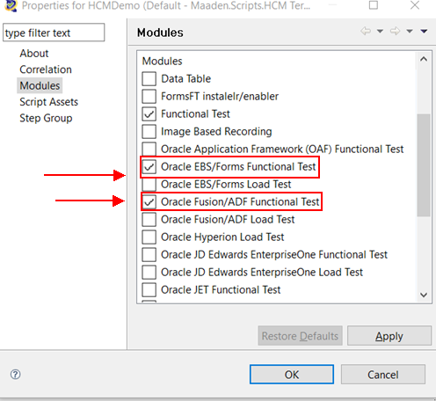

Goals and Objectives of Software Test Automation FrameWork
Automation Testing FrameWork is a way to organize the code so that it can be
- Reusable
- Scalable
- Maintainable
- Understandable
- Workable

FrameWork Setup (DDT)
OATS framework (DDT- Data Driven Testing) has been set up in the windows server.
A set of guidelines like coding standards, test- data handling, object repository treatment, which when followed during automation scripting produce beneficial outcomes like increase code re-usages, higher portability, reduce script maintenance cost etc.

- Data Driven framework are used where automation testing relay on number of input test data.
- It can be removing the hardcoded data from the script and replace with the input test data; hence, they need to pull from external data sources.
- The data source can be CSV, excel, xml and SQL DataBase Table.
- Data Driven FrameWork will have code to pull the test data from any of the data source, which can be then used to populate data on application UI during data entry operations.

FrameWork Structure
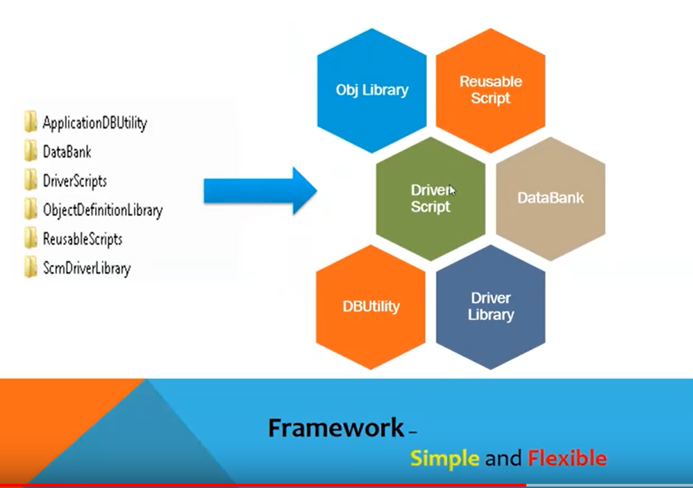

ApplicationDBUtility – This folder will have the library function which is related to the data base. Bacically it deals with the data base activity.
DataBank – As the name suggest, this folder can contains the test data only. It can be CSV file or excel file where you can store the test data which needs to supply to the script during execution.
DriverScripts- As per the requirement, it can call the multiple resuable script and run in integration manner.
ObjectDefinationLibrary- This folder is also know as Object Repository. Object Repository is a collection of object and properties with which OATS will be able to recognize the objects and act on it. When a user records a test, the objects and its properties are captured by default. Without understanding objects and its properties, OATS will NOT be able to play back the scripts. All of the object identification details are captured here on the basic of script which is generated on re-usable script.
ResuableScript- This folder contains the scenario based scripts, which can be re-use whenever it required. It whole logic will be written in this script.

Pictorial diagram – How it works

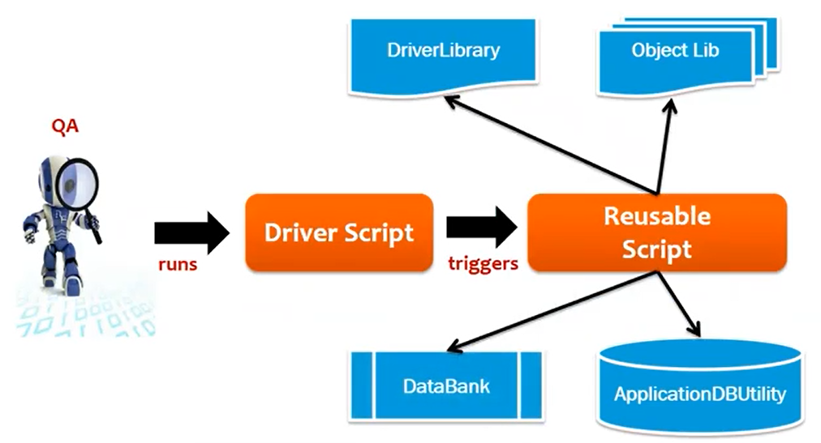

Open Script code snippet
After setup the framework, Sanity verification has been done and it is working fine. Here is the open script code snippet find below.

Java Code Area
Result Report

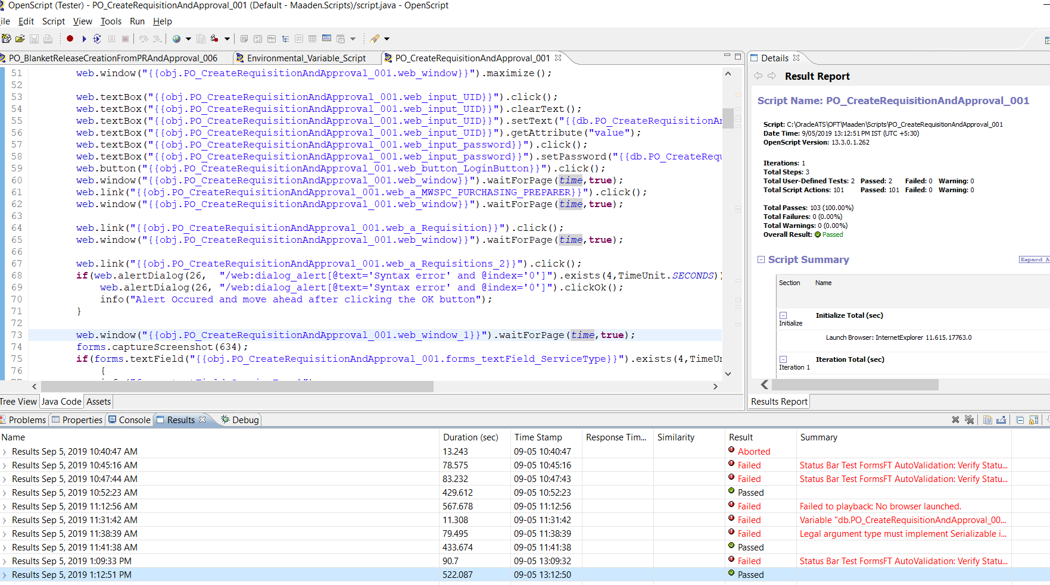

Console/Results/Debug

Test Results
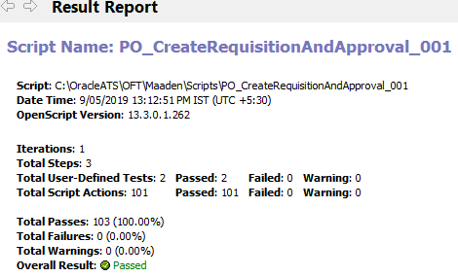
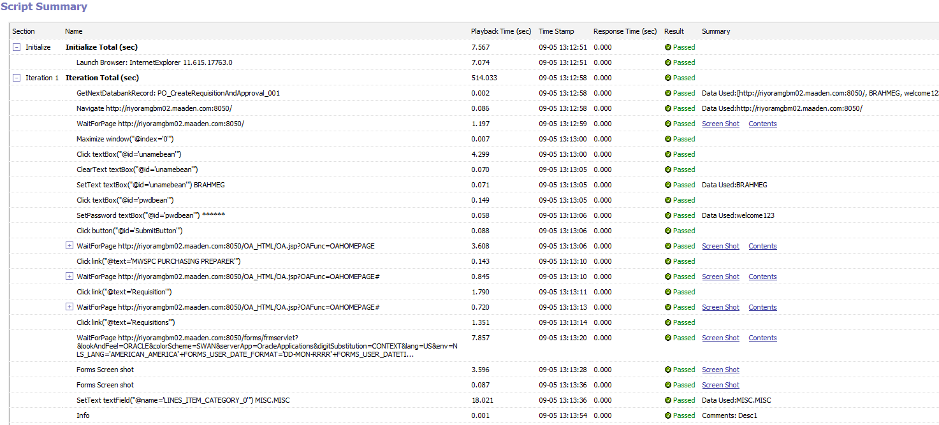
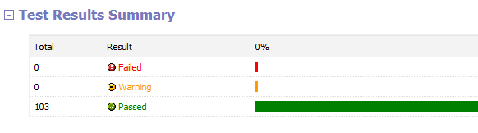

Test Case Execution Results
Below scenarios are executed after setup the framework in the windows server.
Module | Scenarios | Status
Purchasing | Req creation in (Form) and Approval | Pass
Purchasing | Change the Buyer in a Requisition when it's In Process / Approved status | Pass
Purchasing | Standard PO creation from PR and PO Approval | Pass
Purchasing | Standard PO creation without a PR and PO Approval | Pass

Test Results
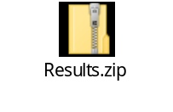

OTM (Oracle Test Manager)
After Test script generation, it can individually, or integrated run will successfully be done by using the open script tool and call that same script into OTM to run it from OTM.
Regression pack needs to be created in the OTM and call all the related driver script/re-usable script in the regression pack.
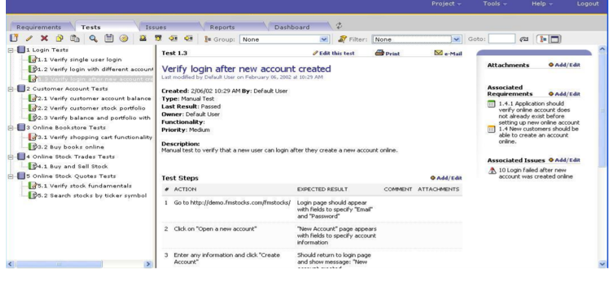

During execution, if any issue will be identified, it can be logging through OTM.
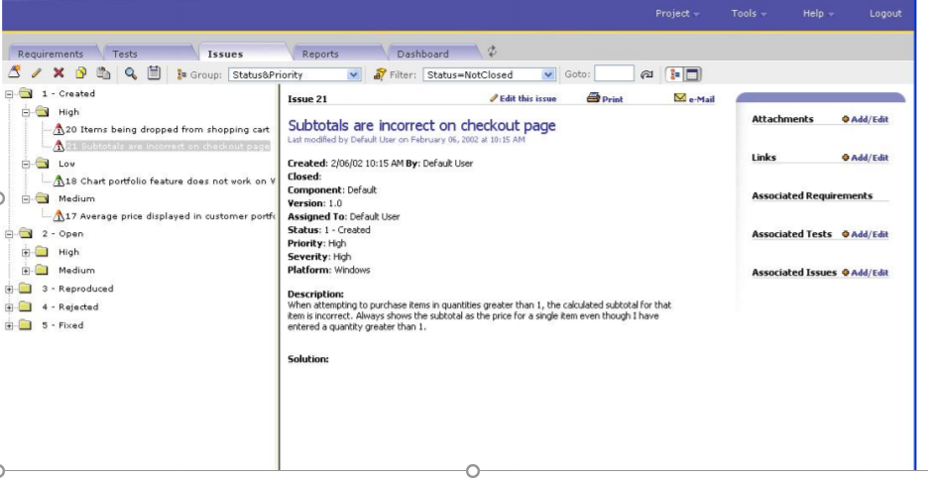

After running the regression pack, report will be generated in OTM.
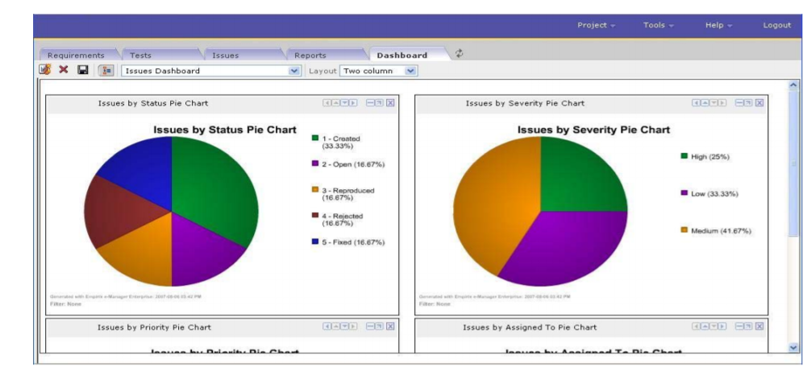

Analysis and Conclusion
During script generation, Dev and PClone instance is being used.
Dev Instance: http://riyoramgbm02.maaden.com:8050/
PClone Instance: http://riysoaclone.maaden.com:8010/

Risk
- The OATS windows server is very much slow as it is in 3rd jump server.
Jump Server 1 (10.2.2.150)-> Jump Server 2 (172.16.6.60)-> Jump Server3 (172.17.11.39)
- Sometimes the application is taking long time to perform the operation in turn, might be the automation script execution got failed or it will take huge time to perform.
- The script might be failed if GL date has expired. Atleast we need to set the GL date open at every month.
- Script might be failed, if application is inconsistence.
- If any property will do modify by developer without prior intimation to tester, the script will be failed.
- If application got crash, then the script will be failed.

Appendix

A – Lesson Learnt
What process/practice needs improvement?
- Ensure the Test cases/scenarios are written/given by the dev team is based on the proper format which can be easily understandable.
- We need to ensure the test cases/ scenarios are not too big. This is making the traceability very difficult

B - monthly deliverable template
Here is the monthly deliverable templated which can be shared every month to the stake holder.
